Pennsylvania State Police

Megan's Law

Absconded Offenders



Photo | Last Name | First Name | Middle Name | YOB | Residential Address | County | Municipality | Police Dept. with Jurisdiction
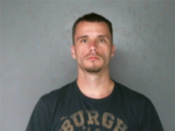 | BROWN | BLAKE | A | 1985 | 1318 BROADWAY AVE, MCKEES ROCKS, PA 15136 | Allegheny | Stowe Twp | STOWE TWP  412-331-4010
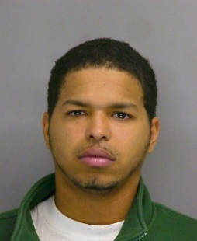 | JOHNSON | EDWARD | WILLIAM | 1986 | ABSCONDED, PITTSBURGH, PA 15221 | Allegheny | Wilkinsburg Boro | WILKINSBURG  412-244-2915
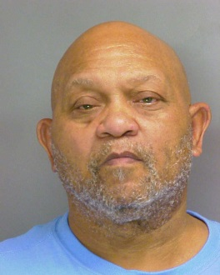 | KENNY | CECIL | GEORGE | 1947 | 6201 BROAD ST APT 110, PITTSBURGH, PA 152064057 | Allegheny | Pittsburgh City | PITTSBURGH CITY PD, SEX ASSAULT UNIT  412-323-7143
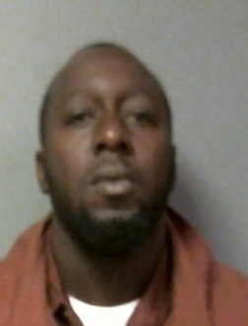 | KENTISH | TREVOR | DWIGHT | 1978 | 3820 PERRYSVILLE AVE, PITTSBURGH, PA 15214 | Allegheny | Pittsburgh City | PITTSBURGH CITY PD, SEX ASSAULT UNIT  412-323-7143
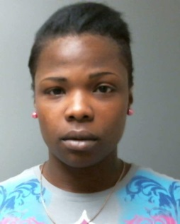 | KNOTT | NADIA | LASHAWN | 1988 | MAYFLOWER ST, PITTSBURGH, PA 15206 | Allegheny | Pittsburgh City | PITTSBURGH CITY PD, SEX ASSAULT UNIT  412-323-7143
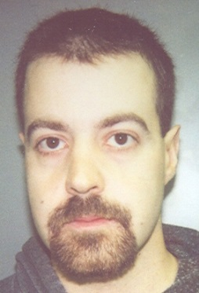 | MCGAFFIC | BRIAN | CRAIG | 1974 | ABSCONDED, WEST MIFFLIN, PA 15122 | Allegheny | West Mifflin Boro | WEST MIFFLIN  412-461-3125
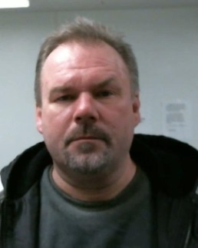 | RICHARD | ROBERT | JOHN | 1966 | 2110 LIDERTAFEL WAY, PITTSBURGH, PA 15212 | Allegheny | Pittsburgh City | PITTSBURGH CITY PD, SEX ASSAULT UNIT  412-323-7143
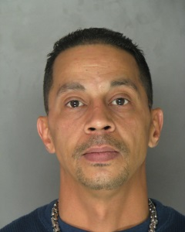 | RUIZ | ENRIQUE |  | 1965 | 1326 TELL STREET, PITTSBURGH, PA 15212 | Allegheny | Pittsburgh City | PITTSBURGH CITY PD, SEX ASSAULT UNIT  412-323-7143
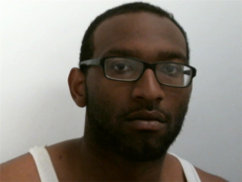 | STEWART | BRADLEY | ALEXANDER | 1990 | 3512 SHADELAND AVE, PITTSBURGH, PA 15212 | Allegheny | Pittsburgh City | PITTSBURGH CITY PD, SEX ASSAULT UNIT  412-323-7143
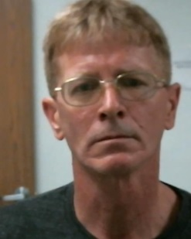 | WATT | NATHAN | S | 1962 | 1201 WOLFRUM STREET, PITTSBURGH, PA 15212 | Allegheny | Pittsburgh City | PITTSBURGH CITY PD, SEX ASSAULT UNIT  412-323-7143
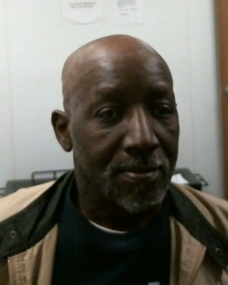 | YOUNGBLOOD | GLENWOOD |  | 1950 | ABSCONDED, PITTSBURGH, PA 15221 | Allegheny | Wilkinsburg Boro | WILKINSBURG  412-244-2915
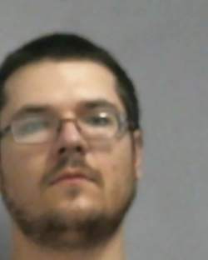 | POOLE | CHARLES | LAWRENCE | 1991 | 701 PENN AVENUE, NEW BRIGHTON, PA 15066 | Beaver | New Brighton Boro | NEW BRIGHTON  724-846-2277
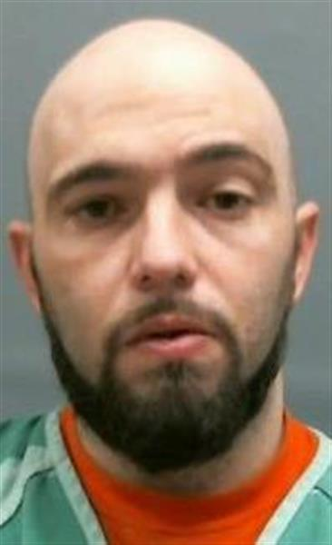 | SMITH | CHRISTOPHER | BERNARD | 1981 | 533 SERVICE CREEK RD., ALIQUIPPA, PA 15001 | Beaver | Independence Twp | INDEPENDENCE TWP  724-775-0880
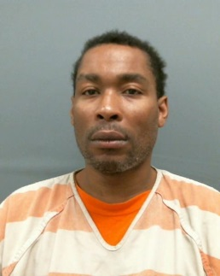 | WIGGINS | ROBERT | OLIVER | 1969 | 1156 FRANKLIN AVE., ALIQUIPPA, PA 15001 | Beaver | Aliquippa City | ALIQUIPPA  724-375-6682
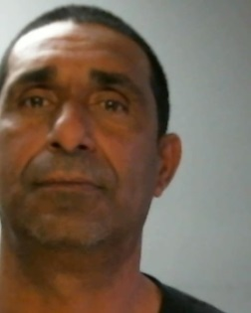 | COTTEMARTINEZ | EDWIN |  | 1966 | 435 SPRING GARDEN STREET, READING, PA 19602 | Berks | Reading City | READING  610-655-6116
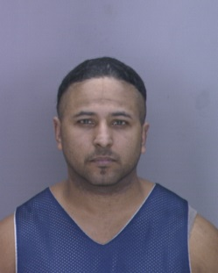 | GARCIA | MANUEL |  | 1974 | ABSCONDED, READING, PA 19601 | Berks | Reading City | READING  610-655-6116
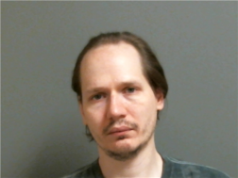 | LYTER | ANDREW | AARON | 1976 | 417 WALNUT STREET, READING, PA 19601 | Berks | Reading City | READING  610-655-6116
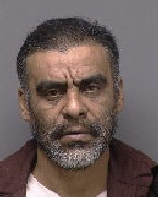 | MARTINEZ | RUDOLPHO | SANTANA | 1964 | ABSCONDED, READING, PA 19601 | Berks | Reading City | READING  610-655-6116
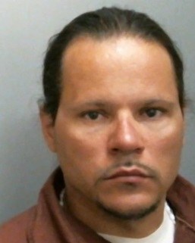 | RAMOS | CARLOS | MANUEL | 1976 | TRANSIENT HOMELESS, READING, PA 19601 | Berks | Reading City | READING  610-655-6116
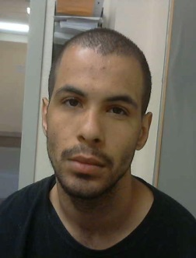 | BOISVERT | KYLE | MICHAEL | 1991 | 2732 5TH AVE, ALTOONA, PA 16602 | Blair | Altoona City | ALTOONA  814-949-2489
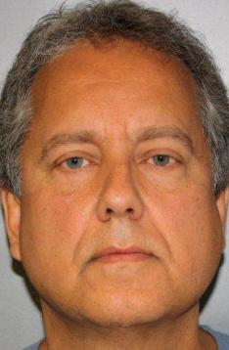 | KUTNYAK | MARK | ALLEN | 1957 | ABSCONDED, PIPERSVILLE, PA 18947 | Bucks | Tinicum Twp | TINICUM TWP  610-348-6610
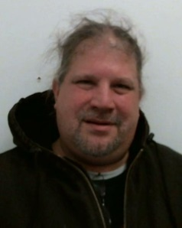 | SIMON | WARREN | GEORGE | 1960 | 61 GRANITE ROAD, LEVITTOWN, PA 19057 | Bucks | Bristol Twp. | BRISTOL TWP POLICE DEPARTMENT  215-785-4052
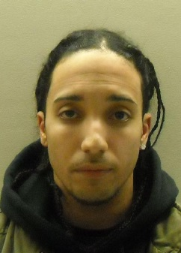 | VASQUEZ | LUIS | MIGUEL | 1985 | 1321 VETERANS HIGHWAY, G7, BRISTOL, PA 19007 | Bucks | Bristol Twp | BRISTOL TWP POLICE DEPARTMENT  215-785-4052
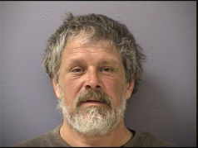 | SCHREFFLER | GLENN | EARL | 1964 | 157 WHITESTOWN ROAD, BUTLER, PA 16045 | Butler | Butler Twp | BUTLER STATE POLICE  724-284-8100
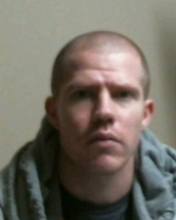 | FINDLEY | ROBERT | SCOTT | 1981 | 484 DOROTHY AVE, JOHNSTOWN, PA 15906 | Cambria | Johnstown City | JOHNSTOWN  814-533-2074
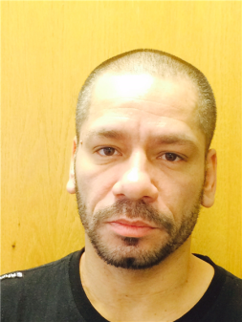 | ROMAN | JUAN | ENRIQUE | 1974 | 670 BEDFORD STREET, JOHNSTOWN, PA 15902 | Cambria | Johnstown City | JOHNSTOWN  814-533-2074
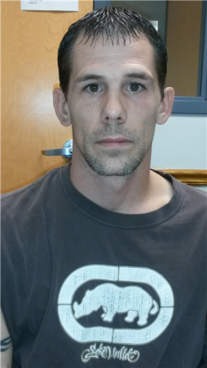 | RYEN | CHAD | VINCENT | 1980 | 4307 ST. STANS AVENUE, NORTHERN CAMBRIA, PA 15714 | Cambria | Northern Cambria Boro | NORTHERN CAMBRIA POLICE DEPARTMENT  814-948-4884
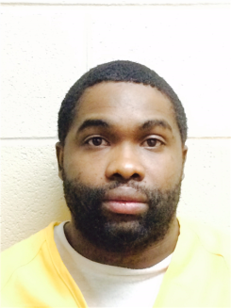 | SCOTT | CARLOS | OMAR | 1984 | 304 GROVE AVE, JOHNSTOWN, PA 15902 | Cambria | Johnstown City | JOHNSTOWN  814-533-2074
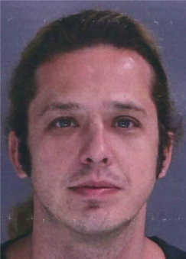 | STENGER | ROY | EDWARD | 1979 | 286 LOWER NIS HOLLOW ROAD, LEHIGHTON, PA 18235 | Carbon | Mahoning Twp | MAHONING TWP  570-386-2241
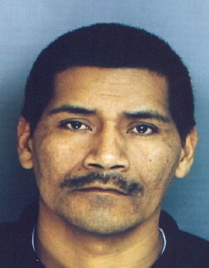 | ALVAREZ | TOMAS | AGUSTIN | 1963 | ABSCONDED, KENNETT SQUARE, PA 19348 | Chester | Kennett Square Boro | KENNETT SQUARE  610-344-5100
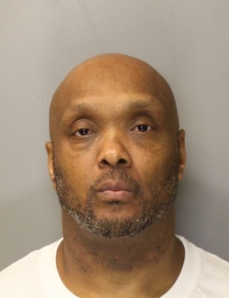 | GRAY | CURTIS | ALLAN | 1964 | 52 N CHURCH ST, SPRING CITY, PA 19745 | Chester | Spring City Boro | SPRING CITY  610-948-3456
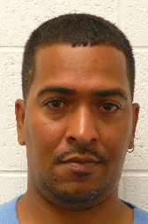 | RIVERA | CARLOS | R | 1974 | 794 S 1ST AVE , COATESVILLE, PA 19320 | Chester | South Coatesville Boro | SOUTH COATESVILLE  610-384-3500
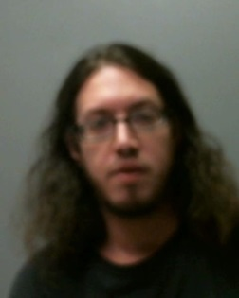 | WELKER | ANDREW | MICHAEL | 1987 | 19 SOUTH 4TH STREET, HALIFAX, PA 17032 | Dauphin | Halifax Boro | HALIFAX REGIONAL  717-558-6900
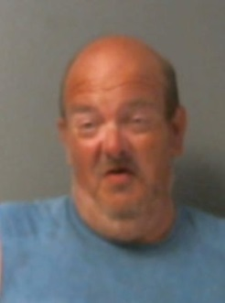 | BROCK | ROBERT | THOMAS | 1964 | HOMELESS, BROOKHAVEN, PA 19015 | Delaware | Brookhaven Boro | BROOKHAVEN  610-892-8400
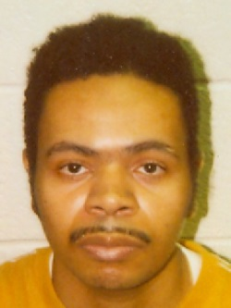 | HARTIE | SEAN |  | 1972 | ABSCONDED, COLLINGDALE, PA 19023 | Delaware | Collingdale Boro | COLLINGDALE  610-586-0502
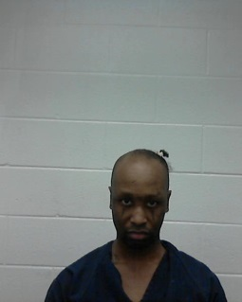 | JONES | JOSHUA |  | 1976 | 87 FORREST RD, SPRINGFIELD, PA 19064 | Delaware | Springfield Twp | SPRINGFIELD TWP  610-544-1100
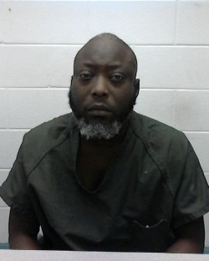 | KULAH | ALFRED |  | 1977 | 501 LONG LANE 2ND FLOOR, UPPER DARBY, PA 19082 | Delaware | Upper Darby Twp | UPPER DARBY TWP  610-352-7050
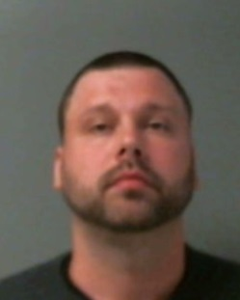 | LONG | WILLIAM |  | 1984 | ABSCONDED, CHESTER, PA 19013 | Delaware | Chester City | CHESTER CITY POLICE (JUVENILE DIVISION)  610-447-8424
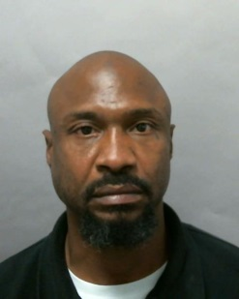 | MOFFIT | DONALD |  | 1968 | 201 EAST 12TH STREET, CHESTER, PA 19013 | Delaware | Chester City | CHESTER CITY POLICE (JUVENILE DIVISION)  610-447-8424
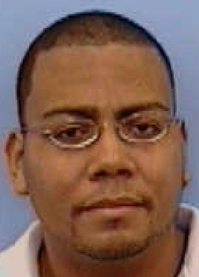 | RAMOS | ROBERTO | CORTIJE | 1972 | ABSCONDED, CHESTER, PA 19013 | Delaware | Chester City | CHESTER CITY POLICE (JUVENILE DIVISION)  610-447-8424
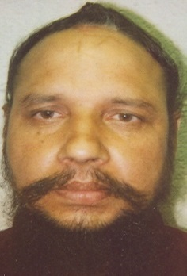 | SINGH | DILJIT |  | 1968 | ABSCONDED, UPPER DARBY, PA 19082 | Delaware | Upper Darby Twp | UPPER DARBY TWP  610-352-7050
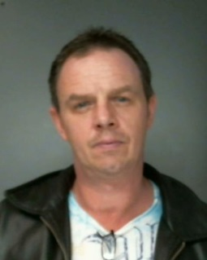 | WIDDOES | KENNETH | FRANK | 1969 | 1603 CHERRY STREET, BOOTHWYN, PA 19061 | Delaware | Upper Chichester Twp | UPPER CHICHESTER TWP  610-485-8400
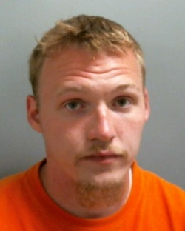 | CLAYPOOLE | JAMIE | ANTHONY | 1991 | ERIE CCC, ERIE, PA 165071403 | Erie | Erie City | ERIE  814-870-1125
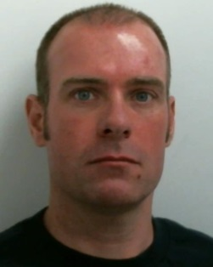 | EDWARDS | WILLIAM | JAMES | 1975 | 170 THOMAS ROAD, MARKLEYSBURG, PA 15459 | Fayette | Henry Clay Twp | UNIONTOWN STATE POLICE  724-439-7111
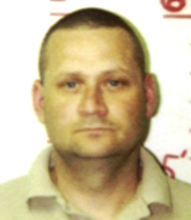 | CASH | MICHAEL | LEE | 1968 | 124 BROWN ST, REYNOLDSVILLE, PA 15851 | Jefferson | Reynoldsville Boro | REYNOLDSVILLE  814-653-2510
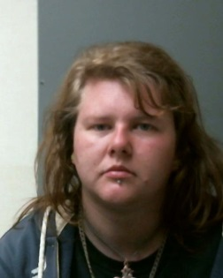 | MALFARA | SAMANTHA | ANNE | 1990 | 14530 RT 28, BROCKWAY, PA 15824 | Jefferson | Snyder Twp | DUBOIS STATE POLICE  814-371-4652
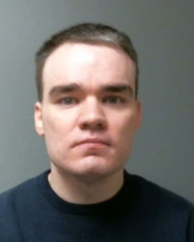 | POTTS | JAMES | JOHN | 1982 | 14530 ROUTE 28, BROCKWAY, PA 15840 | Jefferson | Snyder Twp | DUBOIS STATE POLICE  814-371-4652
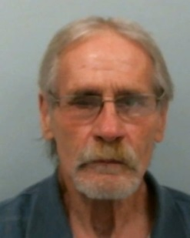 | THOMPSON | CHARLES | CAGLE | 1947 | 182 HILDENE LANE, PUNXSUTAWNEY, PA 15767 | Jefferson | Young Twp | PUNXSUTAWNEY STATE POLICE  814-938-0510
 | KLEIN | HARRY |  | 1964 | ABSCONDED, SCRANTON, PA 18508 | Lackawanna | Scranton City | SCRANTON  570-348-4134
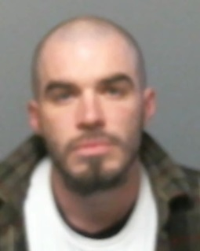 | WHITE | CHAD | GREGORY | 1981 | 427 ST FRANCIS CABRINI AVE., SCRANTON, PA 18504 | Lackawanna | Scranton City | SCRANTON  570-348-4134
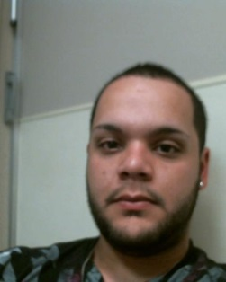 | ALVERIO | RAZIEL |  | 1991 | ALLENTOWN CCC, ALLENTOWN, PA 181012104 | Lehigh | Allentown City | ALLENTOWN POLICE DEPARTMENT  610-437-7721
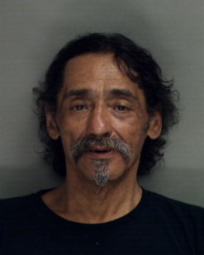 | COLLAZO | LOUIS | J | 1951 | ABSCONDED, ALLENTOWN, PA 18101 | Lehigh | Allentown City | ALLENTOWN POLICE DEPARTMENT  610-437-7721
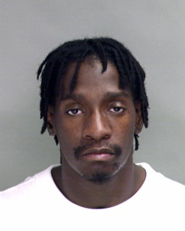 | CRAWFORD | JAMEL |  | 1982 | 424 W GREEN ST, ALLENTOWN, PA 181022468 | Lehigh | Allentown City | ALLENTOWN POLICE DEPARTMENT  610-437-7721
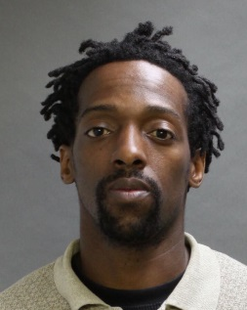 | HICKS | JEROME | MATTHEW | 1975 | 1803 HANOVER AVE, ALLENTOWN, PA 18109 | Lehigh | Allentown City | ALLENTOWN POLICE DEPARTMENT  610-437-7721
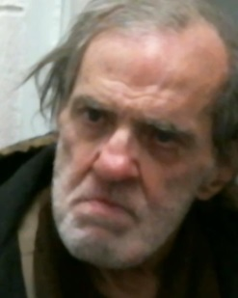 | GEORGE | LLOYD | DAVID | 1946 | 1166 PINE RUN RD, HANOVER TOWNSHIP, PA 187069416 | Luzerne | Hanover Twp. | HANOVER TWP  570-825-1254
 | KRATZER | ALVIN |  | 1960 | 130 CHESTNUT STREET, POTTSTOWN, PA 19464 | Montgomery | Pottstown Boro | POTTSTOWN  610-323-1212
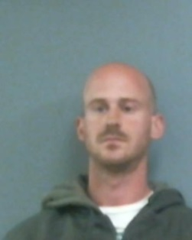 | NAGLE | SEAN | PATRICK | 1985 | 3049 MIDDLE CREEK RD., GILBERTSVILLE, PA 19525 | Montgomery | New Hanover Twp | NEW HANOVER TWP  610-275-1222
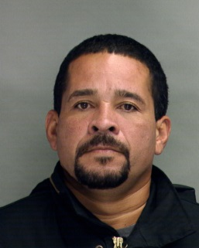 | RAMOS | JOSE | LUIS | 1967 | ABSCONDED, BETHLEHEM, PA 99999 | Northampton | Bethlehem City | BETHLEHEM  610-865-7187
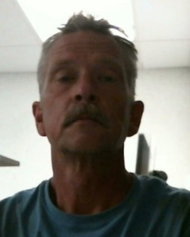 | LUMETTA | TODD | HAROLD | 1966 | 236 CATAWISSA AVENUE, SUNBURY, PA 17801 | Northumberland | Sunbury City | SUNBURY  570-286-4584
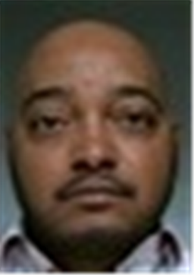 | AUTRY | ANTHONY |  | 1976 | 4826 N CARLISLE ST, PHILADELPHIA, PA 19141 | Philadelphia | Philadelphia City | PHILA. PD SPECIAL VICTIMS UNIT/SVU  215-685-3247
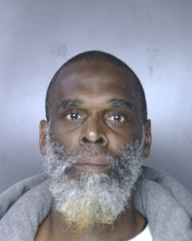 | BRANCH | JAMES | PAUL | 1964 | 4546 N GRATZ ST, PHILADELPHIA, PA 191401030 | Philadelphia | Philadelphia City | PHILA. PD SPECIAL VICTIMS UNIT/SVU 215-685-3247
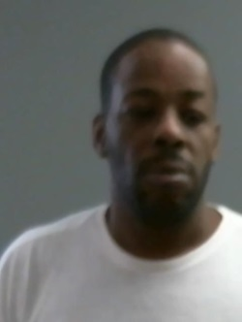 | BROWN | RICHARD |  | 1970 | 4411 NORTH CLEVELAND STREET, PHILADELPHIA, PA 19140 | Philadelphia | Philadelphia City | PHILA. PD SPECIAL VICTIMS UNIT/SVU 215-685-3247
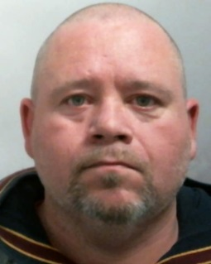 | CARDONICK | DAVID | ROBERT | 1972 | 3136 TULIP ST, PHILADELPHIA, PA 19134 | Philadelphia | Philadelphia City | PHILA. PD SPECIAL VICTIMS UNIT/SVU 215-685-3247
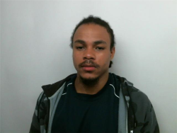 | CARTWRIGHT | REUBEN |  | 1990 | 744 S 52ND STREET, PHILADELPHIA, PA 19143 | Philadelphia | Philadelphia City | PHILA. PD SPECIAL VICTIMS UNIT/SVU 215-685-3247
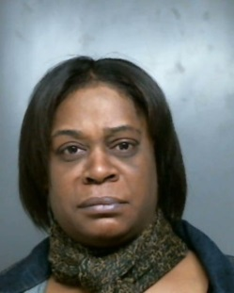 | CHAMBERS | CYMENDA | SAMUEL | 1973 | 6527 BELFIELD AVE, PHILADELPHIA, PA 19119 | Philadelphia | Philadelphia City | PHILA. PD SPECIAL VICTIMS UNIT/SVU 215-685-3247
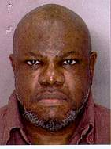 | COLEY | JUNIOUS | CALHOUN | 1955 | 1743 FERNON STREET, PHILADELPHIA, PA 19145 | Philadelphia | Philadelphia City | PHILA. PD SPECIAL VICTIMS UNIT/SVU 215-685-3247
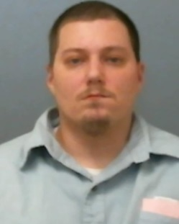 | COLLINS | DENARD | JOSEPH | 1981 | 2436 NORTH DOUGLAS ST, PHILADELPHIA, PA 19132 | Philadelphia | Philadelphia City | PHILA. PD SPECIAL VICTIMS UNIT/SVU 215-685-3247
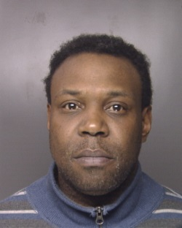 | COOPER | ALLEN |  | 1967 | ABSCONDED, PHILADELPHIA, PA 19143 | Philadelphia | Philadelphia City | PHILA. PD SPECIAL VICTIMS UNIT/SVU 215-685-3247
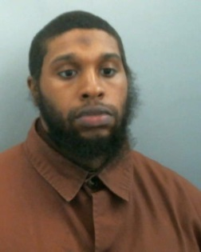 | DOUGLAS | KENNETH |  | 1985 | 613 NORTH 56TH ST, PHILADELPHIA, PA 19131 | Philadelphia | Philadelphia City | PHILA. PD SPECIAL VICTIMS UNIT/SVU 215-685-3247
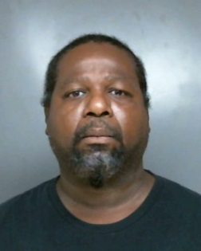 | DOZIER | DARREN | HENRY | 1962 | 508 E. BRINGHURST STREET, PHILADELPHIA, PA 19144 | Philadelphia | Philadelphia City | PHILA. PD SPECIAL VICTIMS UNIT/SVU 215-685-3247
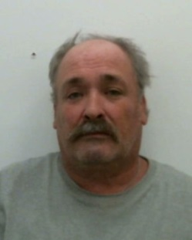 | ELKER | FRANKLIN | KEITH | 1960 | 6727 WOODLAND AVE, PHILADELPHIA, PA 19142 | Philadelphia | Philadelphia City | PHILA. PD SPECIAL VICTIMS UNIT/SVU 215-685-3247
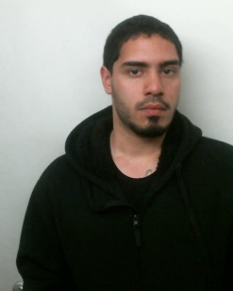 | FLORES | THOMAS |  | 1990 | 4543 N 7TH STREET, PHILADELPHIA, PA 19140 | Philadelphia | Philadelphia City | PHILA. PD SPECIAL VICTIMS UNIT/SVU 215-685-3247
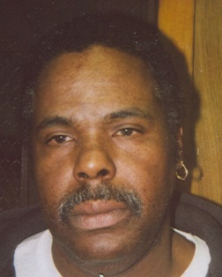 | FRAZIER | ANTHONY | BRUCE | 1958 | ABSCONDED, PHILADELPHIA, PA 19133 | Philadelphia | Philadelphia City | PHILA. PD SPECIAL VICTIMS UNIT/SVU 215-685-3247
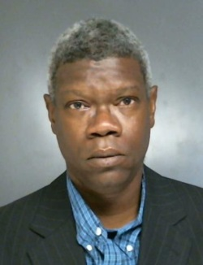 | HILL | DUANE |  | 1957 | 2326 NORTH PARK AVENUE, PHILADELPHIA, PA 19132 | Philadelphia | Philadelphia City | PHILA. PD SPECIAL VICTIMS UNIT/SVU 215-685-3247
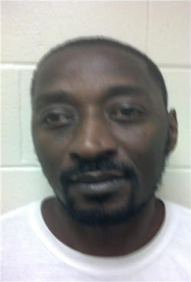 | HILL | RAYMOND | CHARLES | 1970 | 2811 N. 11TH ST., PHILADELPHIA, PA 19132 | Philadelphia | Philadelphia City | PHILA. PD SPECIAL VICTIMS UNIT/SVU 215-685-3247
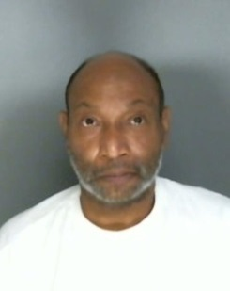 | JAMES | RANDOLPH |  | 1957 | 4401 CONSHOHOCKEN AVE, PHILADELPHIA, PA 19131 | Philadelphia | Philadelphia City | PHILA. PD SPECIAL VICTIMS UNIT/SVU 215-685-3247
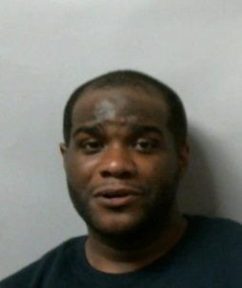 | JOHNSON | DELANTE | ANTHONY | 1972 | 901 HAMILTON STREET, PHILADELPHIA, PA 19123 | Philadelphia | Philadelphia City | PHILA. PD SPECIAL VICTIMS UNIT/SVU 215-685-3247
 | KELSEY | WILLIAM | JACQUAS | 1981 | 301 E. ERIE AVENUE, PHILADELPHIA, PA 19134 | Philadelphia | Philadelphia City | PHILA. PD SPECIAL VICTIMS UNIT/SVU 215-685-3247
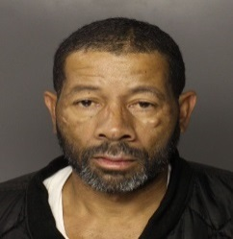 | LEE | JAMES |  | 1958 | 1025 E PRICE ST, PHILADELPHIA, PA 191381806 | Philadelphia | Philadelphia City | PHILA. PD SPECIAL VICTIMS UNIT/SVU 215-685-3247
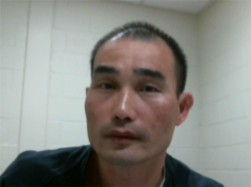 | LEE | KIM |  | 1969 | PHILADELPHIA CFCF, PHILADELPHIA, PA 191360000 | Philadelphia | Philadelphia City | PHILA. PD SPECIAL VICTIMS UNIT/SVU 215-685-3247
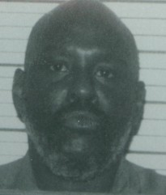 | LEE | OMAR | HAMMONDS | 1947 | ABSCONDED, PHILADELPHIA, PA 19132 | Philadelphia | Philadelphia City | PHILA. PD SPECIAL VICTIMS UNIT/SVU 215-685-3247
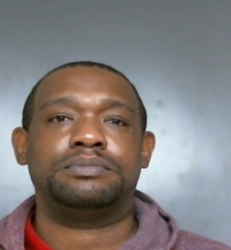 | LEWIS | GUY | LAMONT | 1977 | 1526 S 55TH ST, PHILADELPHIA, PA 191434920 | Philadelphia | Philadelphia City | PHILA. PD SPECIAL VICTIMS UNIT/SVU 215-685-3247
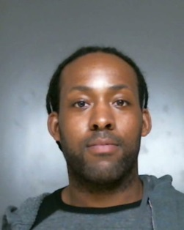 | MACKIE | AUBREY | CLERENCE | 1983 | 8536 PROVIDENT STREET, PHILADELPHIA, PA 19150 | Philadelphia | Philadelphia City | PHILA. PD SPECIAL VICTIMS UNIT/SVU 215-685-3247
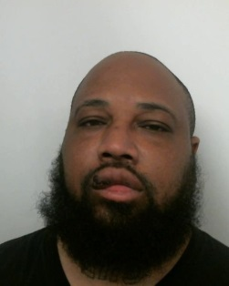 | MCKOY | DEANTE |  | 1975 | 3841 RENO STREET, PHILADELPHIA, PA 19104 | Philadelphia | Philadelphia City | PHILA. PD SPECIAL VICTIMS UNIT/SVU 215-685-3247
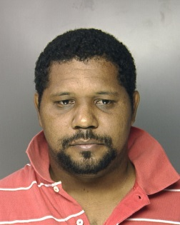 | MONTASMATOS | BENIGNO | E | 1978 | ABSCONDED, PHILADELPHIA, PA 99999 | Philadelphia | Philadelphia City | PHILA. PD SPECIAL VICTIMS UNIT/SVU 215-685-3247
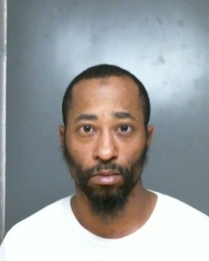 | MORRIS | RASHEED | HAMEED | 1975 | 6822 HORROCKS STREET, PHILADELPHIA, PA 19149 | Philadelphia | Philadelphia City | PHILA. PD SPECIAL VICTIMS UNIT/SVU 215-685-3247
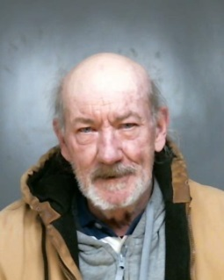 | MROZ | MICHAEL |  | 1946 | 1963 GRANITE ST, PHILADELPHIA, PA 191242142 | Philadelphia | Philadelphia City | PHILA. PD SPECIAL VICTIMS UNIT/SVU 215-685-3247
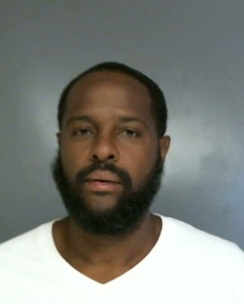 | MUHAMMAD | YASIN | S | 1967 | HOMELESS, PHILADELPHIA, PA 19107 | Philadelphia | Philadelphia City | PHILA. PD SPECIAL VICTIMS UNIT/SVU 215-685-3247
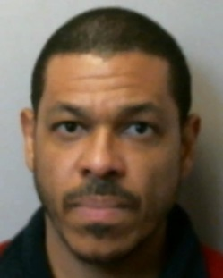 | NARANJO | JOREMI | HELMAR | 1970 | 1447 E LYCOMING ST, PHILADELPHIA, PA 191245364 | Philadelphia | Philadelphia City | PHILA. PD SPECIAL VICTIMS UNIT/SVU 215-685-3247
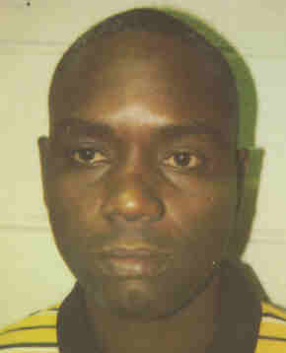 | PALMER | ALONZO |  | 1966 | 1823 SOUTH 31ST STREET, PHILADELPHIA, PA 19145 | Philadelphia | Philadelphia City | PHILA. PD SPECIAL VICTIMS UNIT/SVU 215-685-3247
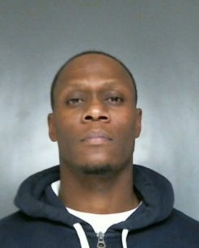 | PASCHALL | HASSAN |  | 1975 | 1901 W ERIE AVE , PHILADELPHIA, PA 19140 | Philadelphia | Philadelphia City | PHILA. PD SPECIAL VICTIMS UNIT/SVU 215-685-3247
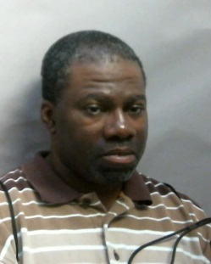 | PASLEY | ANTHONY | KEVIN | 1967 | 301 E. ERIE AVE, PHILADELPHIA, PA 19134 | Philadelphia | Philadelphia City | PHILA. PD SPECIAL VICTIMS UNIT/SVU 215-685-3247
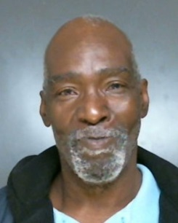 | PLANTER | MITCHELL | G | 1950 | 3021 N WOODSTOCK ST, PHILADELPHIA, PA 191321544 | Philadelphia | Philadelphia City | PHILA. PD SPECIAL VICTIMS UNIT/SVU 215-685-3247
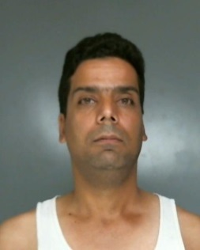 | RIVERA | DAVID |  | 1972 | 4321 ELIZABETH ST, PHILADELPHIA, PA 19124 | Philadelphia | Philadelphia City | PHILA. PD SPECIAL VICTIMS UNIT/SVU 215-685-3247
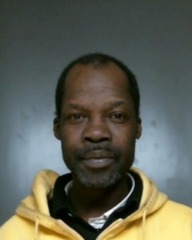 | ROBINSON | JOHN | MICHAEL | 1967 | OUR BROTHERS PLACE, PHILADELPHIA, PA 19123 | Philadelphia | Philadelphia City | PHILA. PD SPECIAL VICTIMS UNIT/SVU 215-685-3247
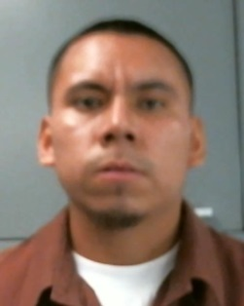 | RODRIGUES | EVON |  | 1989 | 3241 KEIM STREET, PHILADELPHIA, PA 19134 | Philadelphia | Philadelphia City | PHILA. PD SPECIAL VICTIMS UNIT/SVU 215-685-3247
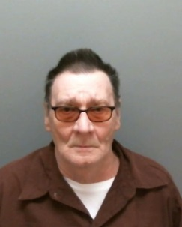 | SCHULTZ | KENNETH | JACKSON | 1947 | 261 S 13TH STREET, PHILADELPHIA, PA 19107 | Philadelphia | Philadelphia City | PHILA. PD SPECIAL VICTIMS UNIT/SVU 215-685-3247
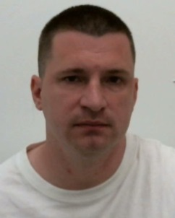 | SELSER | ROBERT | DARYL | 1978 | 4808 VAN KIRK ST, PHILADELPHIA, PA 191354117 | Philadelphia | Philadelphia City | PHILA. PD SPECIAL VICTIMS UNIT/SVU 215-685-3247
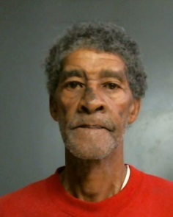 | SHELTON | THOMAS |  | 1950 | 5414 11TH STREET, PHILADELPHIA, PA 19141 | Philadelphia | Philadelphia City | PHILA. PD SPECIAL VICTIMS UNIT/SVU 215-685-3247
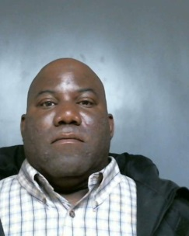 | SOWELL | HENRY |  | 1968 | 907 HAMILTON ST, PHILADELPHIA, PA 19123 | Philadelphia | Philadelphia City | PHILA. PD SPECIAL VICTIMS UNIT/SVU 215-685-3247
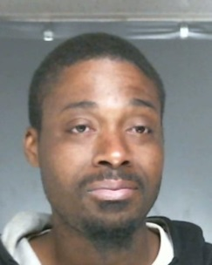 | STANLEY | JUSTIN |  | 1980 | 418 EAST HIGH ST, PHILADELPHIA, PA 19144 | Philadelphia | Philadelphia City | PHILA. PD SPECIAL VICTIMS UNIT/SVU 215-685-3247
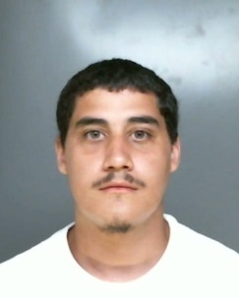 | SUAREZ | DAVID | MIGUEL | 1990 | 2601 NORTH BROAD STREET, PHILADELPHIA, PA 19132 | Philadelphia | Philadelphia City | PHILA. PD SPECIAL VICTIMS UNIT/SVU 215-685-3247
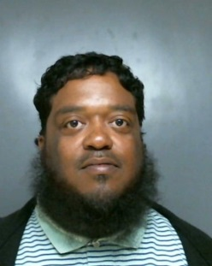 | TAYLOR | MICHAEL |  | 1972 | 507 NORTH ALLISON STREET, PHILADELPHIA, PA 19139 | Philadelphia | Philadelphia City | PHILA. PD SPECIAL VICTIMS UNIT/SVU 215-685-3247
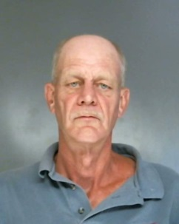 | TEMPLE | WILLIAM | J | 1959 | ST JOHNS HOSPICE, PHILADELPHIA, PA 19107 | Philadelphia | Philadelphia City | PHILA. PD SPECIAL VICTIMS UNIT/SVU 215-685-3247
 | THOMPAS | GEORGE | HENRY | 1959 | ABSCONDED, PHILADELPHIA, PA 19150 | Philadelphia | Philadelphia City | PHILA. PD SPECIAL VICTIMS UNIT/SVU 215-685-3247
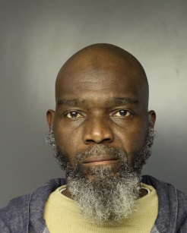 | TORAIN | MICHAEL | CLARENCE | 1956 | 907 HAMILTON ST, PHILADELPHIA, PA 191233815 | Philadelphia | Philadelphia City | PHILA. PD SPECIAL VICTIMS UNIT/SVU 215-685-3247
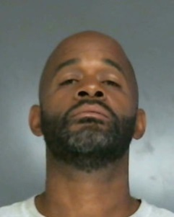 | WAYS | RAYMOND | LINCK | 1969 | 315 S BROAD ST, PHILADELPHIA, PA 19107 | Philadelphia | Philadelphia City | PHILA. PD SPECIAL VICTIMS UNIT/SVU 215-685-3247
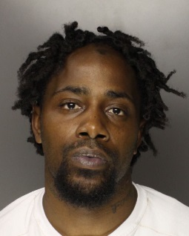 | WELLS | TEIAN |  | 1979 | 808 N 12TH ST, PHILADELPHIA, PA 191231960 | Philadelphia | Philadelphia City | PHILA. PD SPECIAL VICTIMS UNIT/SVU 215-685-3247
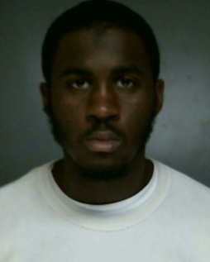 | WESTON | JAMES | RODNEY | 1990 | 6703 NORTH 12TH STREET, PHILADELPHIA, PA 19126 | Philadelphia | Philadelphia City | PHILA. PD SPECIAL VICTIMS UNIT/SVU 215-685-3247
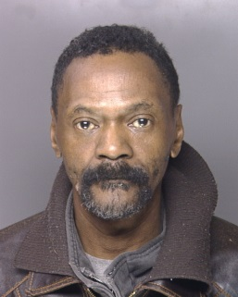 | WILSON | MICHAEL | FREDERICK | 1956 | 4400 W GIRARD, PHILADELPHIA, PA 19104 | Philadelphia | Philadelphia City | PHILA. PD SPECIAL VICTIMS UNIT/SVU 215-685-3247
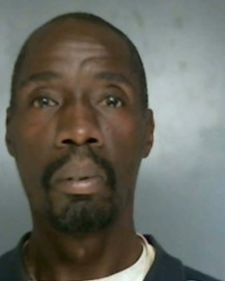 | YOUNG | ROBERT | LEE | 1966 | 332 WEST WOODLAWN STREET, PHILADELPHIA, PA 19144 | Philadelphia | Philadelphia City | PHILA. PD SPECIAL VICTIMS UNIT/SVU 215-685-3247
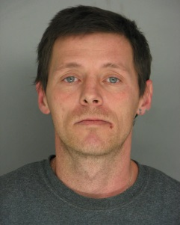 | SIENKO | JAMES | ALLEN | 1973 | 103 HOEHNE CT, GREELEY, PA 184259619 | Pike | Lackawaxen Twp | BLOOMING GROVE STATE POLICE  570-226-5720
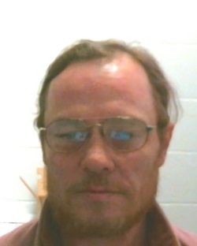 | GATTS | RICKEY | ALAN | 1968 | 262 EAST HALLAM STREET, WASHINGTON, PA 15301 | Washington | Washington City | WASHINGTON  724-223-4226
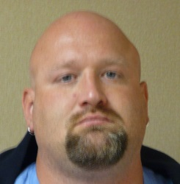 | GRANT | JAMES | ROBERT | 1971 | 538 CONRAD AVE , CHARLEROI, PA 15022 | Washington | North Charleroi Boro | CHARLEROI REGIONAL POLICE DEPARTMENT  724-483-8010
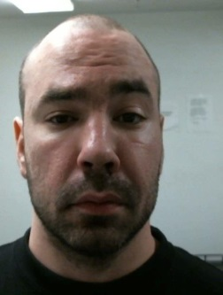 | HOLMES | JASON | HOWARD | 1982 | 2147 KEYSTONE AVE, GREENSBURG, PA 15601 | Westmoreland | Hempfield Twp | GREENSBURG STATE POLICE  814-870-1125
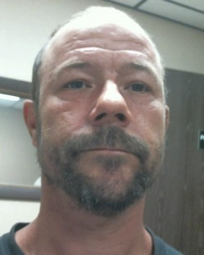 | MOHR | TOBY | DEAN | 1975 | 112 RENAISSANCE LANE, WEST NEWTON, PA 15089 | Westmoreland | South Huntingdon Twp | BELLE VERNON STATE POLICE  724-929-6262
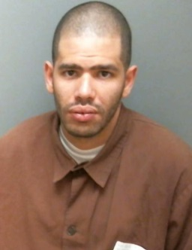 | ACEVEDO | JOSEPH |  | 1985 | 627 E MARKET ST, YORK, PA 17403 | York | York City | YORK  717-846-1234
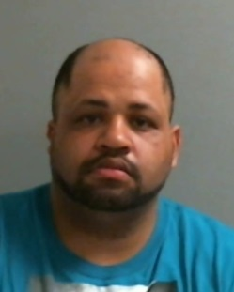 | BELEN | ANTHONY | RAY | 1980 | 238 S DUKE ST, YORK, PA 17401 | York | York City | YORK  717-846-1234

